Module 1: Design Patterns and Principles

Exercise 1: Singleton Pattern
Code:

public class Logger {
private static Logger instance1;
private Logger()
{
System.out.println("Created a logger instance");
}
public static Logger get()
{
if(instance1==null)
{
instance1=new Logger();
}
return instance1;
}
public void log(String message) {
System.out.println("The message is: " + message);
}

public static void main(String[] args)
{
Logger a=Logger.get();
Logger b=Logger.get();
}
}
Output:
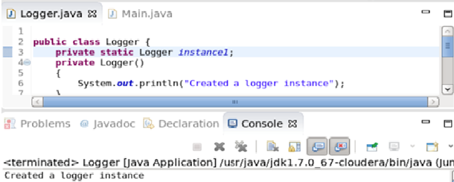

Exercise 2: Factory Method pattern
Code:

public class Main {
public interface Document {
void read();
}
public static class WordDocument implements Document {
public void read() {
System.out.println("I am performing read operation in Word document.");
}
}
public static class PdfDocument implements Document {
public void read() {
System.out.println("I am performing read operation in PDF document.");
}
}
public static class ExcelDocument implements Document {
public void read() {
System.out.println("I am performing read operation in Excel document.");
}
}
public static abstract class DocumentFactory {
public abstract Document createDocument();
}

public static class WordDocFactory extends DocumentFactory {
public Document createDocument() {
return new WordDocument();
}
}
public static class PdfDocFactory extends DocumentFactory {
public Document createDocument() {
return new PdfDocument();
}
}
public static class ExcelDocFactory extends DocumentFactory {
public Document createDocument() {
return new ExcelDocument();
}
}
public static void main(String[] args) {
DocumentFactory wordFactory = new WordDocFactory();
Document wordDoc = wordFactory.createDocument();
wordDoc.read();

DocumentFactory pdfFactory = new PdfDocFactory();
Document pdfDoc = pdfFactory.createDocument();
pdfDoc.read();

DocumentFactory excelFactory = new ExcelDocFactory();
Document excelDoc = excelFactory.createDocument();
excelDoc.read();
}
}

Output:
